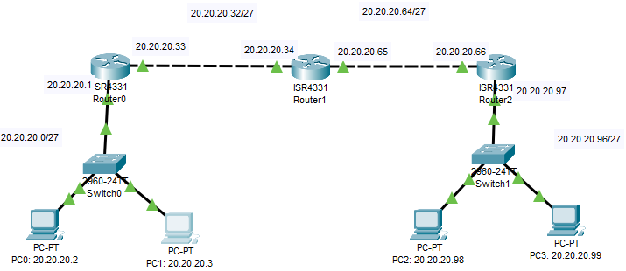
Fig: Topology of the Network

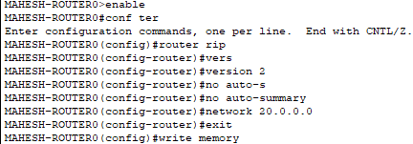
RIP configuration on Router 0

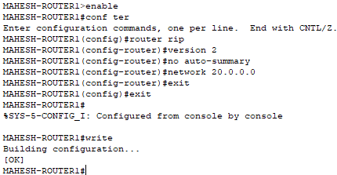
RIP configuration on Router 1

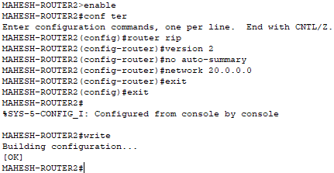
RIP configuration on Router 2

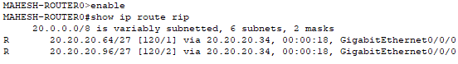
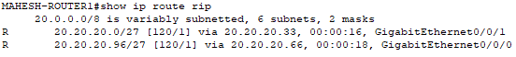
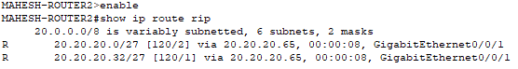
Table: RIP table of each router

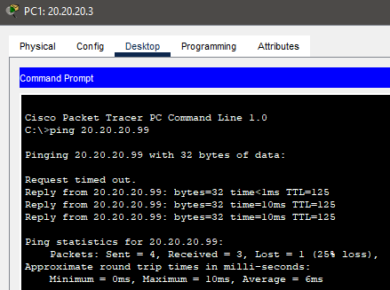
Fig: Test connection using ping command between PC1 to PC3

